**Q1. WACP to check whether a number is odd or even (using simple if statement).**

#include <stdio.h>

int main(){

int x;

printf("Enter a number: ");

scanf("%d", &x);

if (x % 2 == 0)

printf("%d is an even number", x);

else

printf("%d is an odd number", x);

return 0;

}

**Output:**

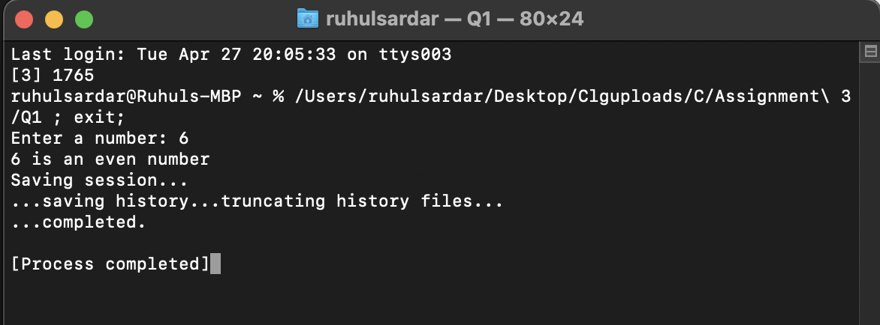

**Q2. WACP to find the roots of a Quadratic equation (using if else statement)**

#include <math.h>

#include <stdio.h>

int main() {

double a, b, c, discriminant, root1, root2, realPart, imagPart;

printf("Enter coefficients a, b and c: ");

scanf("%lf %lf %lf", &a, &b, &c);

discriminant = (b * b) – ( 4 * a * c);

// condition for real and different roots

if (discriminant > 0) {

root1 = (-b + sqrt(discriminant)) / (2 * a);

root2 = (-b - sqrt(discriminant)) / (2 * a);

printf("root1 = %.2lf and root2 = %.2lf\n", root1, root2);

}

// condition for real and equal roots

else if (discriminant == 0) {

root1 = root2 = -b / (2 * a);

printf("root1 = root2 = %.2lf\n", root1);

}

// if roots are not real

else {

realPart = -b / (2 * a);

imagPart = sqrt(-discriminant) / (2 * a);

printf("root1 = %.2lf+%.2lfi and root2 = %.2f-%.2fi\n", realPart, imagPart, realPart, imagPart);

}

return 0;

}

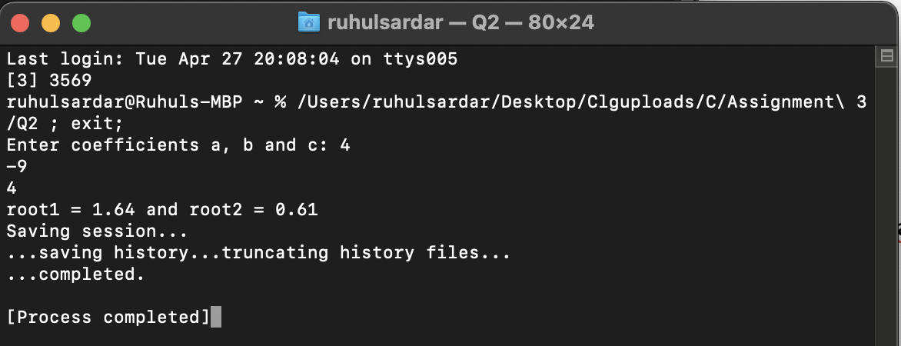

**Output:**

**Q3. WACP to determine whether the character entered is a capital, small case letter, a digit or a special symbol (using else if ladder).**

#include<stdio.h>

int main(){

char ch;

printf("Enter a character: ");

scanf("%c", &ch);

if (ch >= 65 && ch <=90)

{

printf("%c is a capital case letter\n", ch);

}

else if (ch >= 97 && ch <= 122)

{

printf("%c is a small case letter\n", ch);

}

else if (ch >= 48 && ch <= 57)

{

printf("%c is a number\n", ch);

}

else if((ch>=0 && ch<=47) || (ch>=58&& ch<=64) || (ch>=91 && ch<=96) || (ch>=123 && ch<=127))

{

printf("%c is a special symbol\n", ch);

}

return 0;

}

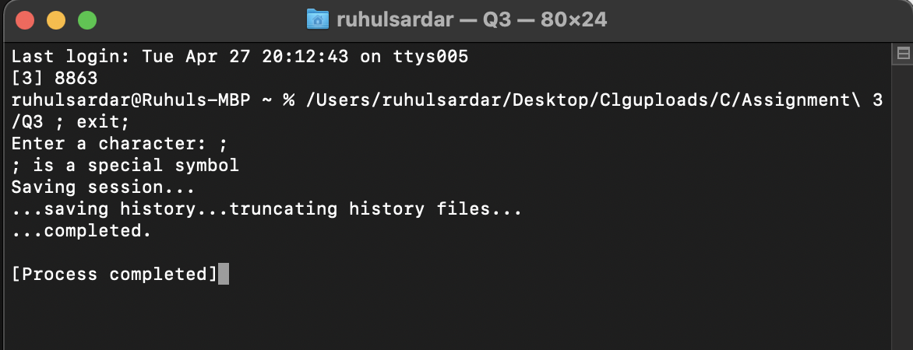**Output:**

**Q4. WACP to add, subtract, multiply and divide two numbers using switch case.**

#include<stdio.h>

int main(){

int a,b,ch;

printf("Enter the 1st number: ");

scanf("%d", &a);

printf("\nEnter the 2nd number: ");

scanf("%d", &b);

printf("\nChoose among 1 for addition , 2 for substraction , 3 for multiplication , 4 for division : ");

scanf("%d", &ch);

switch(ch)

{

case 1 :

printf("%d\n", a+b);

break;

case 2 :

printf("%d\n", a-b);

break;

case 3 :

printf("%d\n", a*b);

break;

case 4 :

printf("%d\n", a/b);

break;

}

return 0;

}

**Output:**

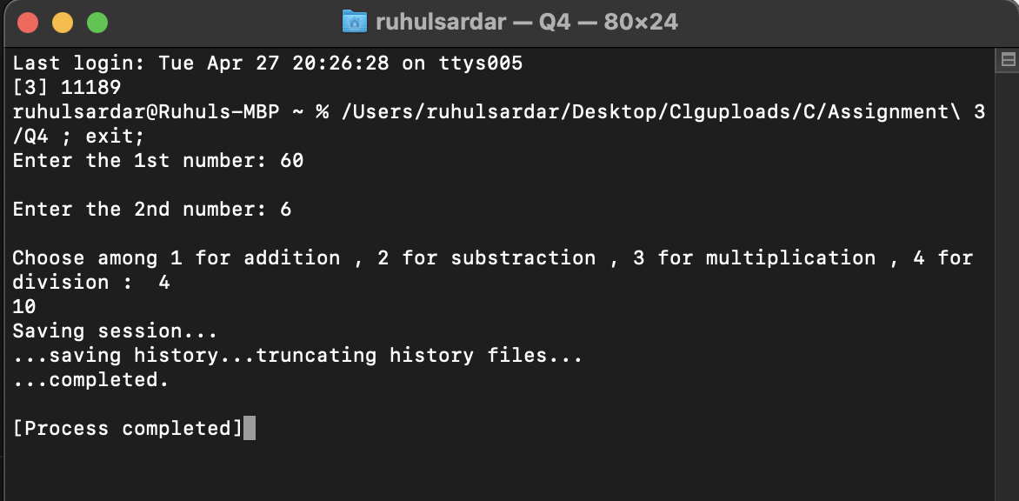

**Q5. Any year is entered through keyboard. WACP to determine whether the year is a leap year or not (using conditional operators).**

#include<stdio.h>

int main()

{

int year;

printf("Enter the year: ");

scanf("%d", &year);

(year%4==0 && year%100!=0) ? (printf("LEAP YEAR\n")) : ((year%400 ==0 ) ? (printf("LEAP YEAR\n")) : (printf("COMMON YEAR\n")));

return 0;

}

**Output:**

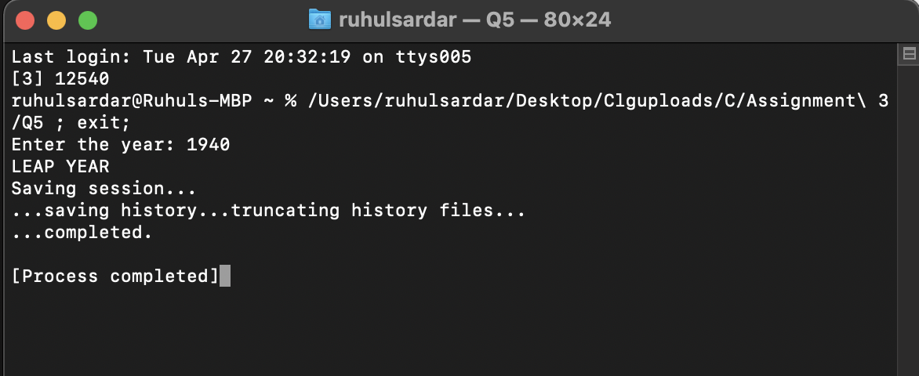

**Q6. Find greatest of three numbers (using ternary operator).**

#include<stdio.h>

int main()

{

int a,b,c,big;

printf("Enter three numbers : ") ;

scanf("%d %d %d", &a, &b, &c) ;

big = (a > b) ? ((a > c) ? a: c):((b > c) ? b:c);

printf("\nThe biggest number is : %d\n", big) ;

return 0;

}

**Output:**

